Ex. No. : 01A Date: 02-02-2026
Register No.: 231701023 Name: S.V.Jashwanth

GUI Components
Aim
Develop an application to change the font and color of the text and display toast message when the user presses the button.
Procedure:

- First, open Android Studio and create a new project with an Empty Activity.

- Choose Kotlin as the language and finish creating the project.

- In the layout file, place a TextView to display text and a few Buttons for changing font and color.

- Open the MainActivity.kt file and link the TextView and Buttons using findViewById.

- Write code so that when the user clicks a button, the text color or font style changes.

- At the same time, show a Toast message to tell the user what change has happened.

- Finally, run the app on an emulator or mobile phone and check the output.

AndroidManifest.xml

<?xml version="1.0" encoding="utf-8"?>
<manifest xmlns:android="http://schemas.android.com/apk/res/android"
xmlns:tools="http://schemas.android.com/tools">
<application
android:allowBackup="true"
android:dataExtractionRules="@xml/data_extraction_rules"
android:fullBackupContent="@xml/backup_rules"
android:icon="@mipmap/ic_launcher"
android:label="@string/app_name"
android:roundIcon="@mipmap/ic_launcher_round"
android:supportsRtl="true"
android:theme="@style/Theme.SizeColorChange">
<activity
android:name=".MainActivity"
android:exported="true">
<intent-filter>
<action android:name="android.intent.action.MAIN" />
<category android:name="android.intent.category.LAUNCHER" />
</intent-filter>
</activity>
</application>
</manifest>

Activity_main.xml

<?xml version="1.0" encoding="utf-8"?>
<LinearLayout xmlns:android="http://schemas.android.com/apk/res/android"
xmlns:app="http://schemas.android.com/apk/res-auto"
xmlns:tools="http://schemas.android.com/tools"
android:id="@+id/main"
android:layout_width="match_parent"
android:layout_height="match_parent"
android:orientation="vertical"
tools:context=".MainActivity" >
<TextView
android:id="@+id/textView"
android:layout_width="match_parent"
android:layout_height="125dp"
android:fontFamily="@font/alegreya_medium"
android:gravity="center"
android:text="Hello World!"
android:textSize="20sp" />
<Button
android:id="@+id/btnIncrease"
android:layout_width="match_parent"
android:layout_height="wrap_content"
android:layout_marginLeft="20dp"
android:layout_marginTop="40dp"
android:layout_marginRight="20dp"
android:fontFamily="@font/alegreya_medium"
android:text="Increase Text Size"
android:textSize="16sp" />
<Button
android:id="@+id/btnDecrease"
android:layout_width="match_parent"
android:layout_height="wrap_content"
android:layout_marginLeft="20dp"
android:layout_marginTop="40dp"
android:layout_marginRight="20dp"
android:fontFamily="@font/alegreya_medium"
android:text="Decrease Text Size"
android:textSize="16sp" />
<Button
android:id="@+id/btnTextColor"
android:layout_width="match_parent"
android:layout_height="wrap_content"
android:layout_marginLeft="20dp"
android:layout_marginTop="40dp"
android:layout_marginRight="20dp"
android:fontFamily="@font/alegreya_medium"
android:text="Change Text Color"
android:textSize="16sp" />
<Button
android:id="@+id/btnBgColor"
android:layout_width="match_parent"
android:layout_height="wrap_content"
android:layout_marginLeft="20dp"
android:layout_marginTop="40dp"
android:layout_marginRight="20dp"
android:fontFamily="@font/alegreya_medium"
android:text="Change Background Color"
android:textSize="16sp" />
</LinearLayout>

MainActivity.kt

package com.example.sizecolorchange
import android.graphics.Color
import android.os.Bundle
import android.widget.Button
import android.widget.LinearLayout
import android.widget.TextView
import androidx.activity.enableEdgeToEdge
import androidx.appcompat.app.AppCompatActivity
import androidx.core.view.ViewCompat
import androidx.core.view.WindowInsetsCompat
import kotlin.random.Random
class MainActivity : AppCompatActivity() {
private var textSize=20f
override fun onCreate(savedInstanceState: Bundle?) {
super.onCreate(savedInstanceState)
enableEdgeToEdge()
setContentView(R.layout.activity_main)
val btnIncrease=findViewById<Button>(R.id.btnIncrease)
val btnDecrease=findViewById<Button>(R.id.btnDecrease)
val btnTextColor=findViewById<Button>(R.id.btnTextColor)
val btnBgColor=findViewById<Button>(R.id.btnBgColor)
btnIncrease.setOnClickListener {
val textView=findViewById<TextView>(R.id.textView)
textSize+=2f
textView.textSize=textSize
}
btnDecrease.setOnClickListener {
val textView=findViewById<TextView>(R.id.textView)
if(textSize>10f) {
textSize -= 2f
textView.textSize = textSize
}
}
btnTextColor.setOnClickListener {
val textView=findViewById<TextView>(R.id.textView)
textView.setTextColor(randomColor())
}
btnBgColor.setOnClickListener {
val mainLayout=findViewById<LinearLayout>(R.id.main)
mainLayout.setBackgroundColor(randomColor())
}
ViewCompat.setOnApplyWindowInsetsListener(findViewById(R.id.main)) { v, insets ->
val systemBars = insets.getInsets(WindowInsetsCompat.Type.systemBars())
v.setPadding(systemBars.left, systemBars.top, systemBars.right, systemBars.bottom)
insets
}
}
private fun randomColor(): Int {
return Color.rgb(
Random.nextInt(256),
Random.nextInt(256),
Random.nextInt(256)
)
}
}

Output
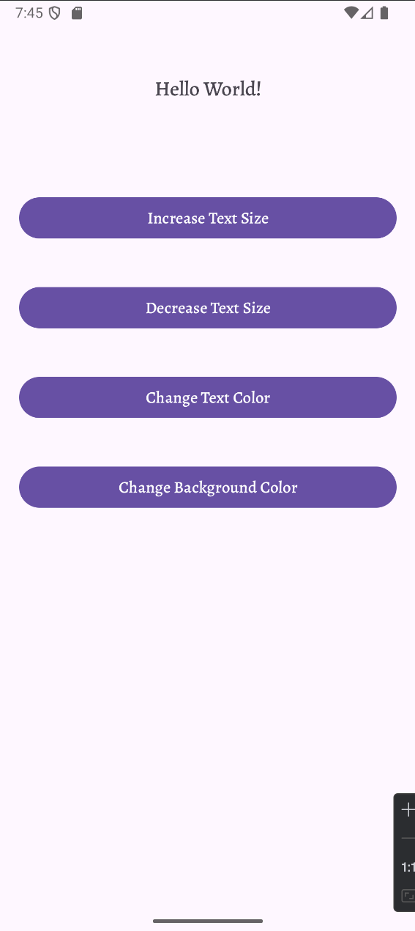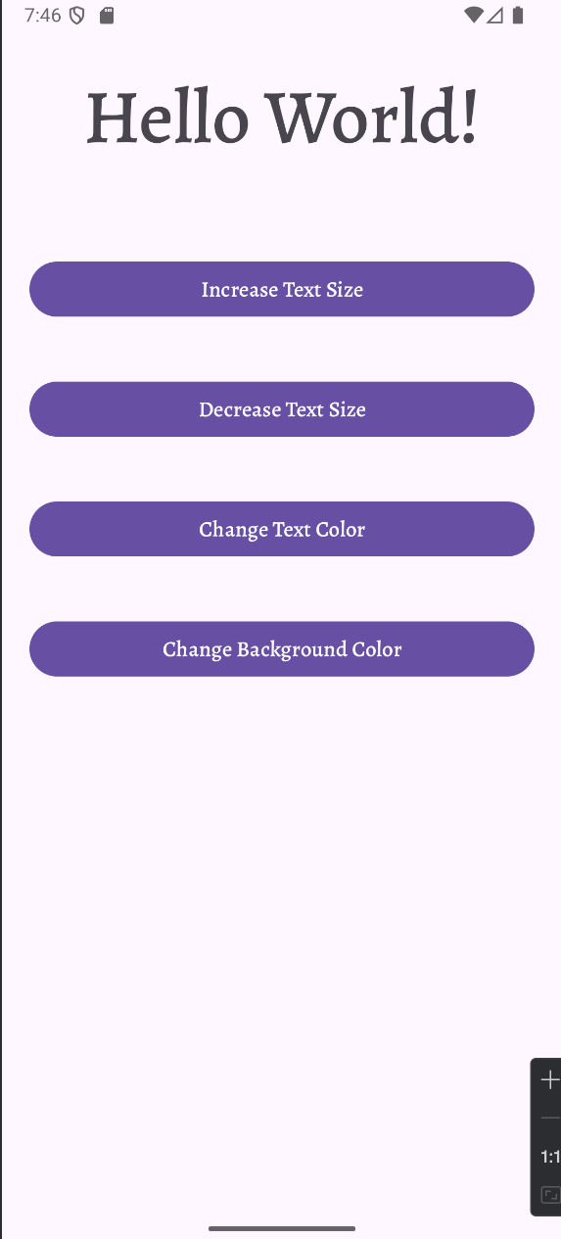

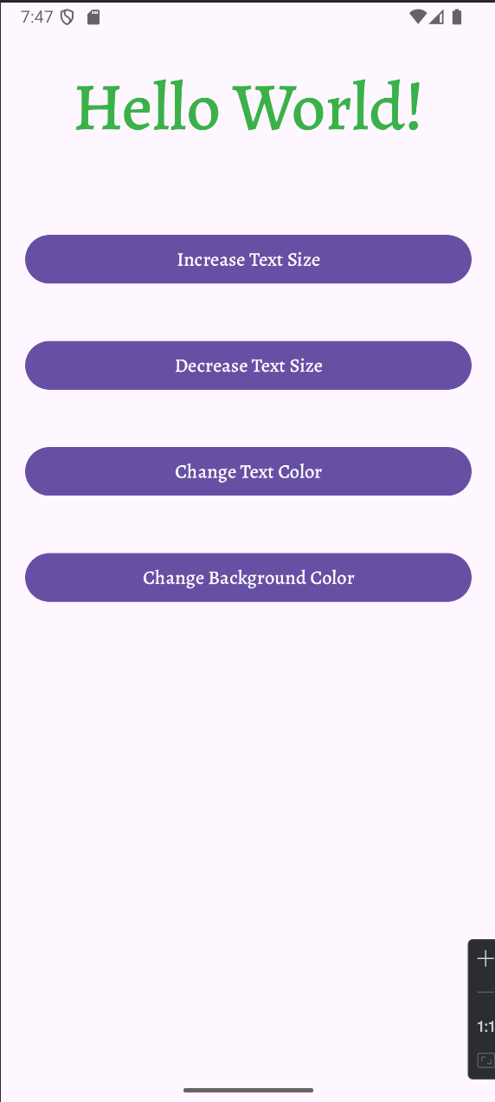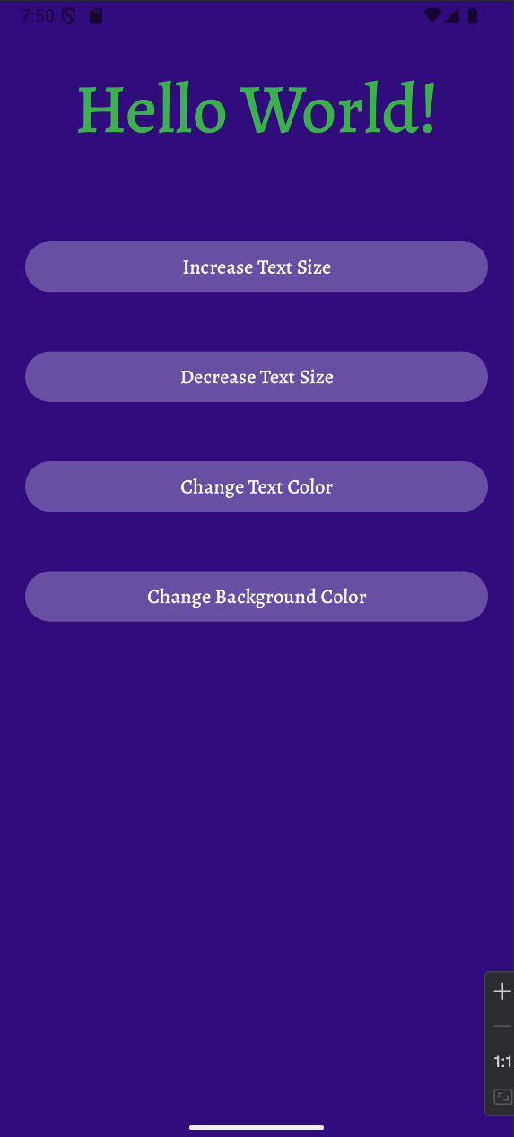

Result:
The application successfully allows the user to increase or decrease the font size, change the text color, and change the background color using buttons.

